Class 6
Data Manuplation Project Guide

General Info
- The Project term is between 14 August and 31 August.
- The project consists of 2 sprints and each sprint is 1 week.
- There will be 3 teams and each team will comprise 4 people.
- Each team will have 1 mentor. Mentors are Kadir Efe, Serkan, Fatih Fidan
- There will be a 30 minutes meeting with teammates every day.
- The content of the daily meeting is generally as follows:
  - What each person did
  - The general direction in the project
  - Task sharing until tomorrow
- A meeting will be held with the mentor on the specified dates.
- Each person in the team will tell about the part he did to the mentor in the meeting. After each meeting, the mentor will make an assessment of whether each team member is working or not.
- After the project is completed, an online project presentation will be made with the STAR or CAR method in 15 minutes each.

Meeting Schedule
- Project Introduction Meeting: Sunday, August 14, 21:00
- Daily Scrum Meeting: Every day between 15 August and 28 August
- Retrospective Meeting / Sprint Planing Meeting: Sunday, 21- 28 August 21:00
- Project Presentations: Wednesday, 31 August 21:00

Content of the Project
In this project you will work on a dirty dataset scraped from autoscout24.com. You scraped this website in the Data Gathering Project, so you will be working with a dataset you are familiar with. Click here to reach the dataset .
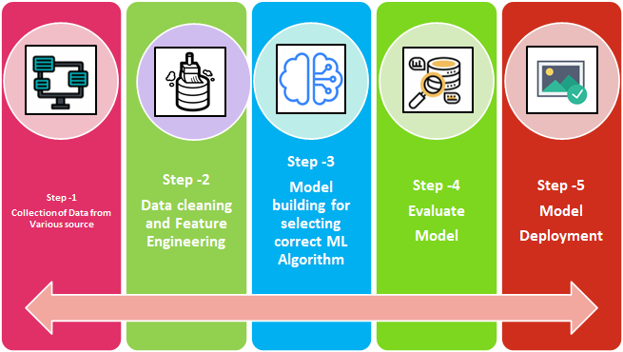
This project is an Exploratory Data Analysis(EDA) project focusing on "Step-2" shown in the graphic above. Exploratory Data Analysis refers to the critical process of performing initial investigations on data so as to discover patterns,to spot anomalies and to check assumptions with the help of summary statistics and graphical representations.
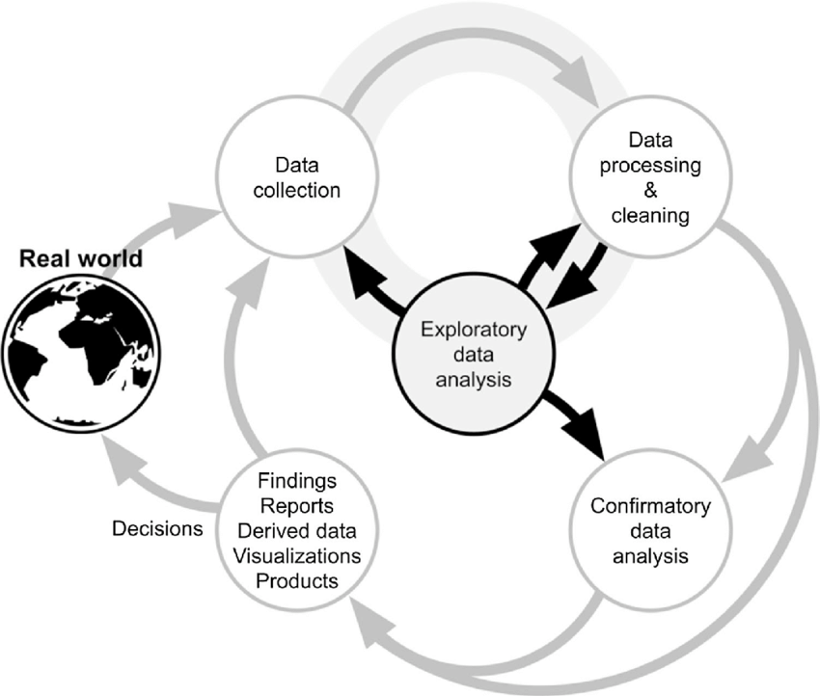
The ultimate goal is to extract useful insights from the dataset and make the dataset ready for training for Machine learning. The project consists of 4 parts:
1-Data Cleansing: The process of detecting and correcting (or removing) corrupt, incorrect, duplicate or meaningless records from a dataset. REGEX and Pandas methods will be used effectively for this purpose.
2-Dealing with Missing Values: One or more of the following approaches are applied when dealing with missing values.
- Deleting rows and columns with relatively many missing values
- Impute missing values for continuous or categorical variable
- Using general imputation methods (Mean, median, mode, ffill/bfill)
- Using Algorithms that support missing values
- Prediction of missing values
3-Outlier Analysis: Visualization and mathematical techniques are used to handle Outliers.
The following methods can be used to view the Outliers.
- Boxplots, Quartile Analysis (IQR)
- Z-score
The following techniques can be used to interfere with the Outliers.
- Trimming/removing the outlier
- Quantile-based flooring and capping
- Mean/Median imputation
- Deleting the outliers
- Data transformation (log, root, winsorization)
- Using statistical tests
- Valuing the outliers
- Digitalizing of Numeric Data
- Diversity reduction with clustering
4-Data Visualization: It is an approach to analyzing datasets to summarize the main features of the dataset using statistical graphs. The point is to see what the data can tell us before machine learning modeling. With the help of Data visualization tools of Python, we will try to get useful insights and capture hidden patterns in the dataset.
The following libraries can be used to interfere with the Outliers.
- Pandas
- Matplotlib
- Seaborn
- Plotly
At the end of the project, An ML model will be trained with the clean dataset obtained by each teams and the results will be shared with them. Thus, by looking at the success of the ML model (R Squared and RMSE Value), it will be measured how successful the teams have made a data manipulation project.

Suggestions
- Each team will work on the same dataset. Each member of a team will share the features according to their difficulty level. Click the link to look at the difficulties of the features.
- Each team will have a common google colab notebook. Each team member will work on his/her own notebook. After completed the task, he/she will add it to the team’s common notebook.
- Combining the different notebooks is a challenging issue. It should be taken into account and resolved that there may be incompatibilities between Python codes from different team members.
- For each feature, it is recommended to open a header in the notebook and work under it. It is important that your notebook is clear and understandable when your teammate or someone else reads it. For this reason, you should explain what the functions you code will be used for and the function parameters.
- stackoverflow and pandas tutorial should be used effectively.

Tips and Tricks
- The price column is the target feature. Therefore, observations with NaN values ​​here should be dropped. This is something that should be done at the very beginning of the project.
- If a function you coded takes a long time to run, reducing the number of rows in the dataset to be processed may be a solution. A random sample dataset of 10k is taken and the notebook is run with it. When it is seen that all the processing steps have been completed successfully, the notebook is finally run with the entire dataset.
- Features that do not contain any useful data are dropped.
- Values that are obvious to be wrong are replaced with NaN values and filled with a suitable method.
- The featurs containing more than 90% missing value will be dropped.
- You can combine two features and try to create a meaningful new feature. This process is called feature engineering. Therefore, while focusing on your own features, you can check whether there is a possibility to combine other features and do feature engineering.
- Only one of the features that are highly correlated with each other is used, the other(s) are dropped. Features with high correlation are considered the same feature and duplicate feature and duplicate observation are not requested in the dataset.
- The standard pearson correlation is something that is looked at in numeric features, but you can also look at the correlation in categorical features.
(Note: Numeric correlation is not considered in a feature that takes a value of 1 and 0. 1 and 0 are digitized, in fact, they are categorical, not numerical.)
- https://towardsdatascience.com/the-search-for-categorical-correlation-a1cf7f1888c9
- https://en.wikipedia.org/wiki/Cram%C3%A9r%27s_V
- If there are too many unique values ​​in a categorical feature, if possible, “Diversity reduction with clusterings” method can be used for this purpose.
- Feature engineering examples:
  - You can make a separate feature by subtracting the age of the car from the vehicle registration date.
  - You can make a separate feature from the car brand to which country it belongs to.
  - You combine the make and model of the car and make a new feature called make_model.
  - You can group from location to 12 provinces and reduce the diversity.
- Be careful working with comfort_convenience, entertainment_media, safety_security and extras.
  - There are some missing l letters at the end of the list, you can correct them (conrol and wheel words).
  - After handling the missing values, making encoding is recommended. You can use str.get_dummies() to encode these columns. it is very practical. (https://www.geeksforgeeks.org/python-pandas-series-str-get_dummies/)
  - You can do all data cleansing operations with
    - str.extract
    - str.replace
    - str.strip
    - str.get_dummies
    - str.split
- If fuel_type is a fossil fuel, the value of co2_emissions cannot be 0. So in these cases, the value of co2_emissions should be set to NaN.
- If the frequency rate of a categorical feature you make df[*].value_counts(dropna=False, normalize=True) is below 1/1000, you can consider diversity reduction.
- Rare vehicle models that have less than 30 observations should be dropped. This is because for machine learning model training, seeing at least 30 samples from a car model allows it to make healthier predictions.
(Note: You may remember from the statistics course, it is expected to have at least 30 observations for the z-test. Therefore, the condition of having at least 30 observations should be accepted as treshold and lines with rare vehicle models should be dropped).
- The fuel_consumption value is expected to be approximately [3-18] in terms of domain knowledge for fossil fuel vehicles. Outside of this range can be made NaN value.
- At certain points in the notebook, you can export the partially cleaned dataset with df.to_pickle("......."). Therefore, if the session crashes, you can read the dataframe from the point that you saved with read_pickle and continue. Running the notebook from the beginning in each session causes a waste of time.
- It is checked whether there is a duplicate observation with df.duplicated().sum() at the beginning of the project and at the end of the EDA. If there are, these lines are dropped.
- One of the dummy columns with more than 90% correlation with each other should be dropped.

